Dear Fellow GFWC Sisters,

What an honor it is to welcome you to the 2024-2026 Administration as the 37th GFWC Director of Junior Clubs! I look forward to serving alongside you all as we continue the impactful work for which we are known. GFWC Clubwomen are dedicated to community improvement by enhancing the lives of others through volunteer service, and we are passionate, creative, and untiring advocates as we work together. I love that we also have so much fun and build wonderful relationships with each other while we work hard!

The guiding concept for the Junior Administration will be “Stronger Together.” We are stronger when we work together at all three levels of GFWC membership: Women’s Clubs, Juniors, and Juniorettes. Our multi-generational membership is truly one of the benefits of belonging, and we can accomplish so much together. We will support existing Junior clubs and charter new Junior clubs nationwide. We will empower State Directors of Junior Clubs and encourage and equip Junior clubs in states without Directors. We will utilize technology to help ALL Junior members feel connected to GFWC and to each other, including learning about the numerous resources available to all members. We will participate in the goals and vision of the GFWC Strategic Plan and continue to promote and develop the Junior Certification Program available to all Junior and Juniorette clubs.

Advocates for Children continues to be the Juniors’ Special Program. We will encourage clubs to plan projects for their favorite local organizations and/or March of Dimes, St. Jude’s, and Prevent Child Abuse America. We will celebrate Advocates for Children Week the fourth week of October and encourage all clubs to participate. More information about the Juniors’ Special Program is available in the GFWC Club Manual.

I am at your service, along with the entire GFWC Junior leadership, to help engage clubs at all membership levels in celebrating our rich history while looking ahead to a strong future for GFWC. As we work together, we are Stronger Together!

In Junior Love,
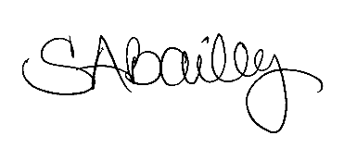
Shannon Bailey, GFWC Director of Junior Clubs

